**MovRec**

A mini-project report submitted for

**Internet Programming (Semester V)**

by

Name of individual group member

Sagar Darji

Komal Darji

Karan Doshi

As the partial fulfilment of the requirement for the degree of Bachelor in Information Technology

Guided by

Prof. Anusha Vegesna



Department of Information Technology

D. J. Sanghvi College of Engineering,

Mumbai – 400 056

2018 - 2019



CERTIFICATE

This is to certify that the following students have submitted the mini-project report for the project titled

**MovRec**

At D. J. Sanghvi College of Engineering, Mumbai as a partial fulfilment of the requirement for the degree of Information Technology (Semester V) of University of Mumbai in the year 2018 – 2019.

Student Name SAP ID

Komal Darji 60003160012 Sagar Darji 60003160013 Karan Doshi 60003160015

Internal Guide      Internal Examiner

(Prof. Anusha Vegesna)

External Examiner         HOD, IT Dept.                                                                            (Dr. Neepa Shah)



**Declaration**

We declare that this written submission represents our ideas in our own words and where others' ideas or words have been included, we have adequately cited and referenced the original sources. We also declare that we have adhered to all principles of academic honesty and integrity and have not misrepresented or fabricated or falsified any idea/data/fact/source in our submission. We understand that any violation of the above will be cause for disciplinary action by the Institute and can also evoke penal action from the sources which have thus not been properly cited or from whom proper permission has not been taken when needed.

Komal Darji

----------------------------------------- -----------------------------------------

Sagar Darji

----------------------------------------- -----------------------------------------

Karan Doshi

----------------------------------------- -----------------------------------------

----------------------------------------- -----------------------------------------

(Name of student and SAP ID) (Signature)

Date:

# A

# Acknowledgement

We wish to express our sincere gratitude to Dr. Hari Vasudevan Principal and Mrs. Neepa Shah H.O.D of IT Department of Dwarkadas. J. Sanghvi College of Engineering for providing us the opportunity to do our Project work on MovRec. This Project bears on imprint of many peoples. We sincerely thank our project guide Ms. Anusha Vegesna for her guidance and encouragement in carrying out this Project. We would like to thank Mrs. Mitchell D’silva for her constant help and support during the entire session of the project. We are also thankful to the college for providing us with the necessary resources and also a many thanks to the staff of college for their valuable co-operation. Many people, especially our classmate and team members itself, have made valuable suggestions to this proposal which gave us an inspiration to improve our project. We thank them all for their help to complete our report.

# B

# List of Figures

2.1.1 Sitemap for the website.

2.2.1 Software requirements for the project.

2.3.1 Timeline of the project.

3.1.3.1 Main page.

3.1.3.2 About page.

3.1.3.3 Contact page.

3.1.3.4 Web Structure page.

3.1.3.5 Search page.

3.1.3.6 Sign up page.

3.1.3.7 Log in page.

3.1.4.1 Database Design.

4.1 Main page of the website.

4.2 Web structure page.

4.3 Recommendation available to the user on Web structure page.

4.4 Login modal on the Main page

4.5 –Login page

4.6 – Sign up page

4.7 – Search page

4.8 Contact Us page

4.9 About page

C

# List of Tables

2.2.1 Software requirements for the project.

2.3.1 Timeline of the project.

5.1 Testing and Deployment table.

# D

# Table of Contents

**1. Analysis**

1.1. Motivation/Need of the project/Objectives

1.2. Problem Definition

1.3. Scope

**2. Planning**

2.1. Sitemap/ Navigation

2.2. Computing environment

2.3. Project implementation schedule

**3. Design**

3.1. Construction and Design

3.1.1. Designing site structure

3.1.2. Navigation

3.1.3. Page layouts

3.1.4. Database Design

**4. Implementation**

**5. Testing and Deployment**

**6. Future Scope**

**7. References**

**8. Assignment No. 01**

**9. Assignment No. 02**

1

1. **Analysis**
   1. Motivation/Need of the project/Objectives

The topic for our project is movie recommendation system. We came across this topic and decided to choose this as the project because we use websites like Netflix and Amazon Prime Video regularly and we don’t know how these websites work and especially recommend movies to users based on their taste of movies. On gathering information about movie recommendation system we realized that recommendation can be done much better by using machine learning algorithms. This helped us to know a lot of new terms related to Machine Learning like collaborating filtering, K means filtering etc.

* 1. Problem Definition

The project aims to develop a recommendation system whose primary objective is to suggest movies by using data clustering and computational intelligence. The recommendations will be made based on the genre and the links that the user visits, which will be taken care of by the Web application, while an online server will collect the data, save them in a database and process them to come up with the predictions. These applications take advantage of the fact that users increasingly place their trust in reviews that are coming from more people and some of them offer the possibility of creating an account and keeping track of submitted reviews, ratings and past experiences.

* 1. Scope

The project helps all the users to attain the information about the clicked image i.e. if a user clicks on the image of a movie he gets a web like structure showing details of the movie like the director, the male actor, the female actor and the genre. Thus giving information about the movie, the actors, the director and the genre. Then on the basis of the movies clicked by the user and the genre he views the most; the user will be recommended movies of his choice and also by looking at the pattern the algorithm will

2

see the pattern followed by another user and if same it will recommend movies that the other user has selected.

1. **Planning**
   1. Sitemap/ Navigation

HOME

Login in

Search

Contact us

Feedback

Sign up

Web structure

About us

Fig: 2.1.1 – Sitemap for the website.

* 1. Computing environment

|  |  |  |
| --- | --- | --- |
| **Front-End** | **Back-End** | **Tools** |
| **Languages**   * HTML5 * CSS4 * JavaScript * Bootstrap * Python | **Languages**   * PHP * JavaScript   **Databases**   * PHPmyadmin | * GoJS * Jupyter notebook * Windows 10 * Web browser-Google Chrome * Sublime text * XAMPP * Internet Connection installation of web frameworks |

Fig: 2.2.1 – Software requirements for the project

3

Hardware Requirements:

* Laptop / PC

1. Intel core i5 processor
2. 4 GB RAM
3. 1 TB Hard-disk
   1. Project implementation schedule

|  |  |  |  |  |
| --- | --- | --- | --- | --- |
| Sr No. | Task name | Duration | Start | Finish |
| 1 | Selecting the topic for the project. | 7 days | 23-07-2018 | 30-07-2018 |
| 2 | Planning the site and its layouts. | 3 days | 31-07-2018 | 02-08-2018 |
| 3 | Researching ML algorithms suitable for Recommendation. | 10 days | 03-08-2018 | 12-08-2018 |
| 4 | Researching for a Web structured UI and finding GoJS for the same. | 15 days | 13-08-2018 | 27-08-2018 |
| 5 | UI for Login, Sign Up and Main page. | 7 days | 28-08-2018 | 04-09-2018 |
| 6 | Understanding GoJS and manipulating it. | 10 days | 05-09-2018 | 14-09-2018 |
| 7 | Designing the database | 1 day | 15-09-2018 | 15-09-2018 |
| 8 | Filling the Database. | 1 day | 16-09-2018 | 16-09-2018 |
| 9 | Implementing the ML algorithm in python | 12 days | 17-09-2018 | 29-09-2018 |
| 10 | Merging it with our website | 5 days | 30-09-2018 | 04-10-2018 |
| 11 | Testing | 5 days | 05-10-2018 | 09-10-2018 |
| 12 | Documentation | 10 days | 10-10-2018 | 19-10-2018 |

Fig: 2.3.1 – Timeline of the project.

4

1. **Design**
   1. Construction and Design
      1. Designing site structure

* Linear site structure
  + 1. Navigation

As soon as the Home page opens the user is given options in the navbar as to where to go. On clicking on the About tab he will be directed to the about page giving information about the website. The next tab is the Contact Us page giving the user the liberty to ask queries related to the site. The feedback page is provided to the user to let him provide us with suggestions as to what problems did he face or what are the things that can be enhanced in the website. The search icon redirects the user to the search page letting him search and get information about the searched movie. The sign up tab lets the user to create a new account and the login tab opens a pop up letting the user to log into the website.

* + 1. Page layouts

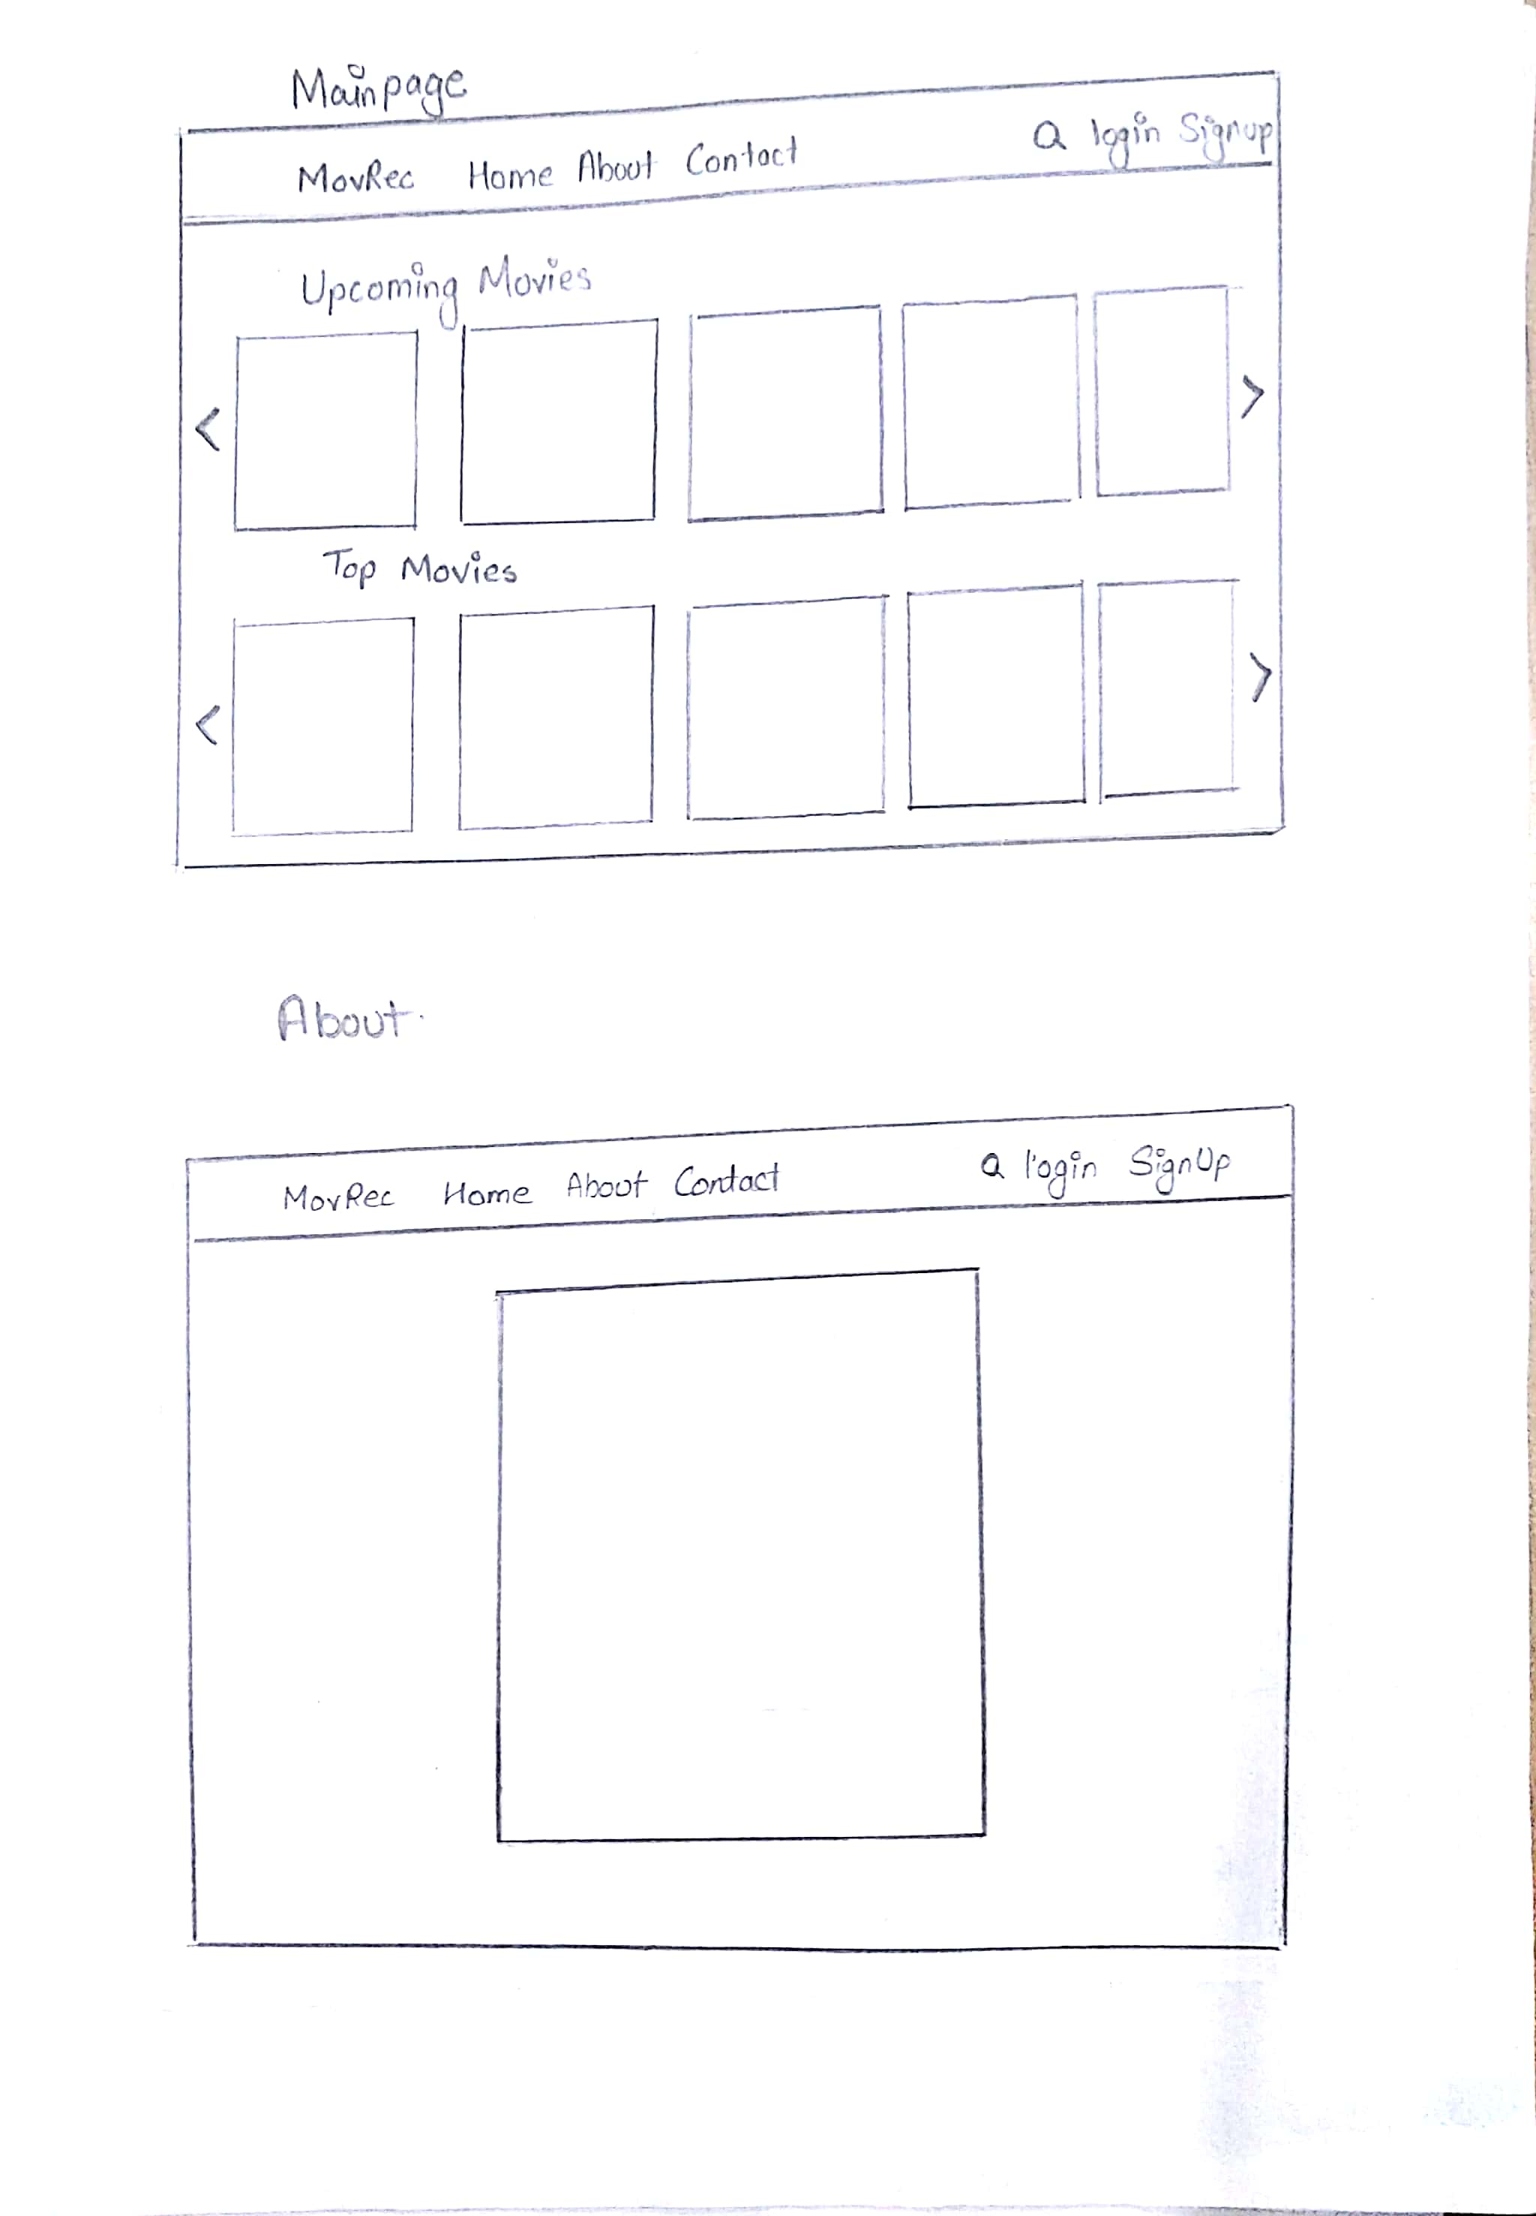

Fig: 3.1.3.1– Main page

5



Fig: 3.1.3.2 – About page.

6

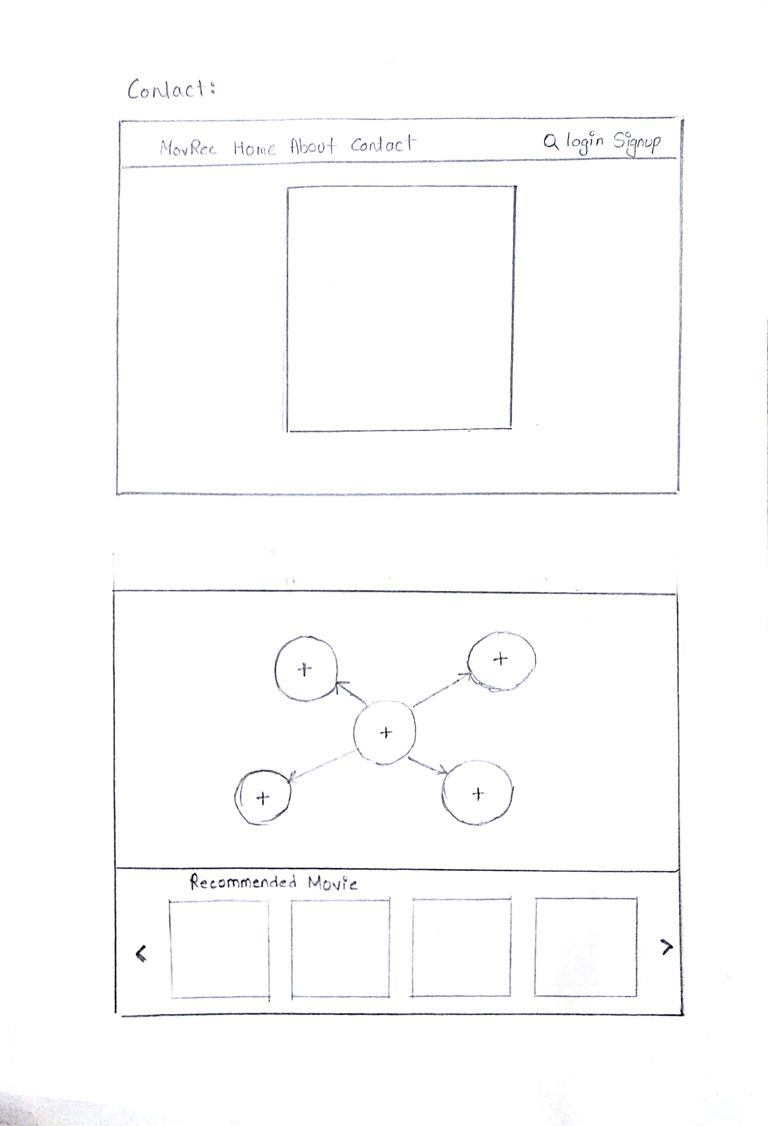

Fig: 3.1.3.3 – Contact page

7



Fig: 3.1.3.4– Web Structure page

8

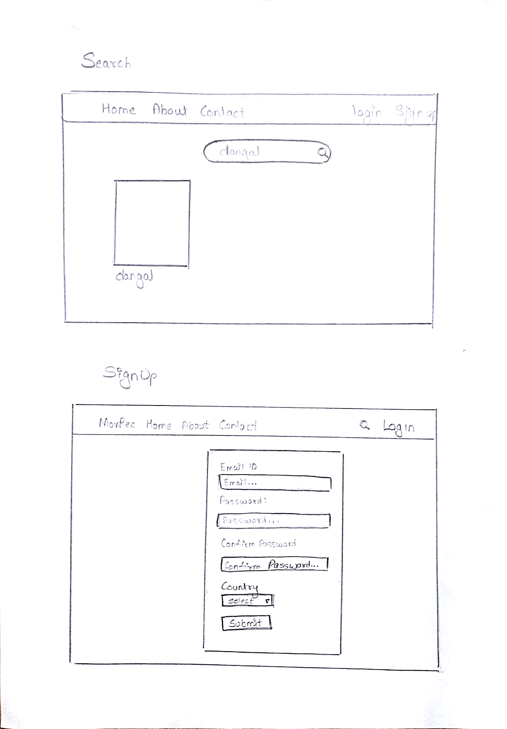

Fig: 3.1.3.5– Search page

9



Fig: 3.1.3.6– Sign up page.

10

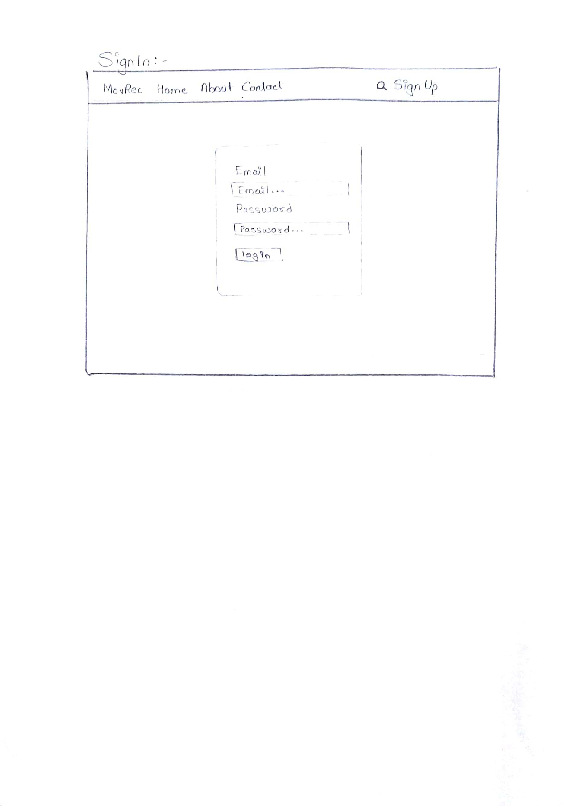

Fig: 3.1.3.7– Log in page.

* + 1. Database Design

11

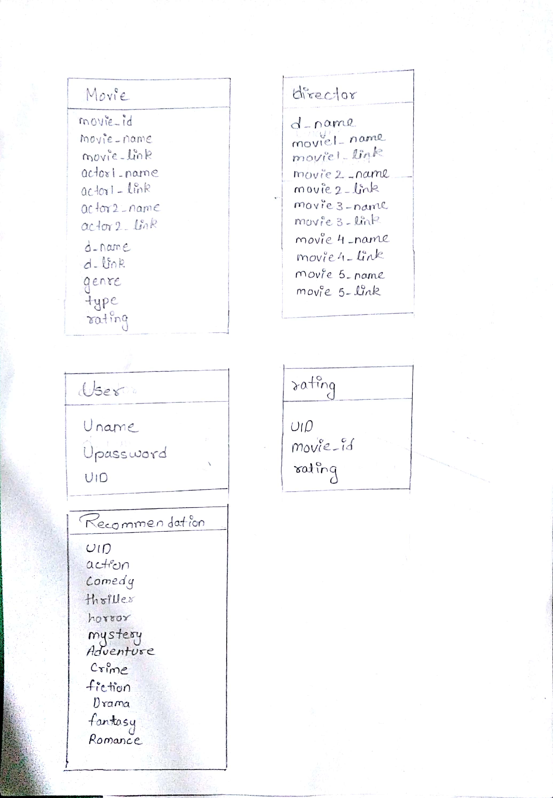

Fig: 3.1.4.1 – Database Design.

12

1. **Implementation**

Main page: It is the home page of MovRec which displays the upcoming and top movies to the user. The user can click on any of the movies and go to the next page i.e. web structure.php for further information.

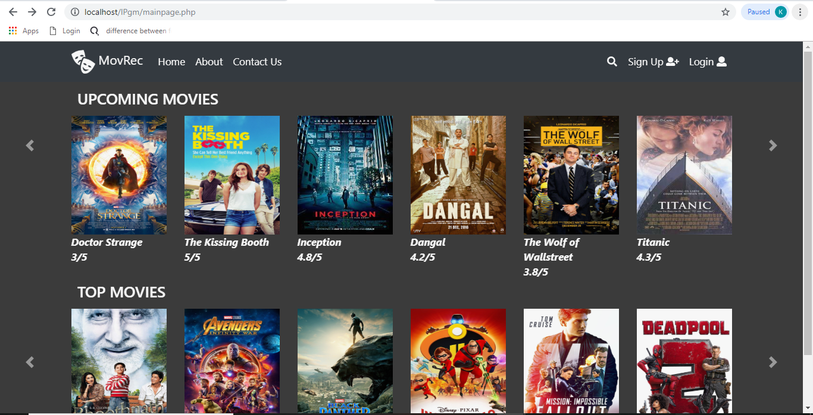

Fig: 4.1 – Main page of the website.

Web structure.php – This page is the full detailed information about the clicked movie i.e. it contains the lead actors, director and genre of the movie. On further clicks on the respective circles it shows related data. Example for director it shows the three movies that the director has made.

13

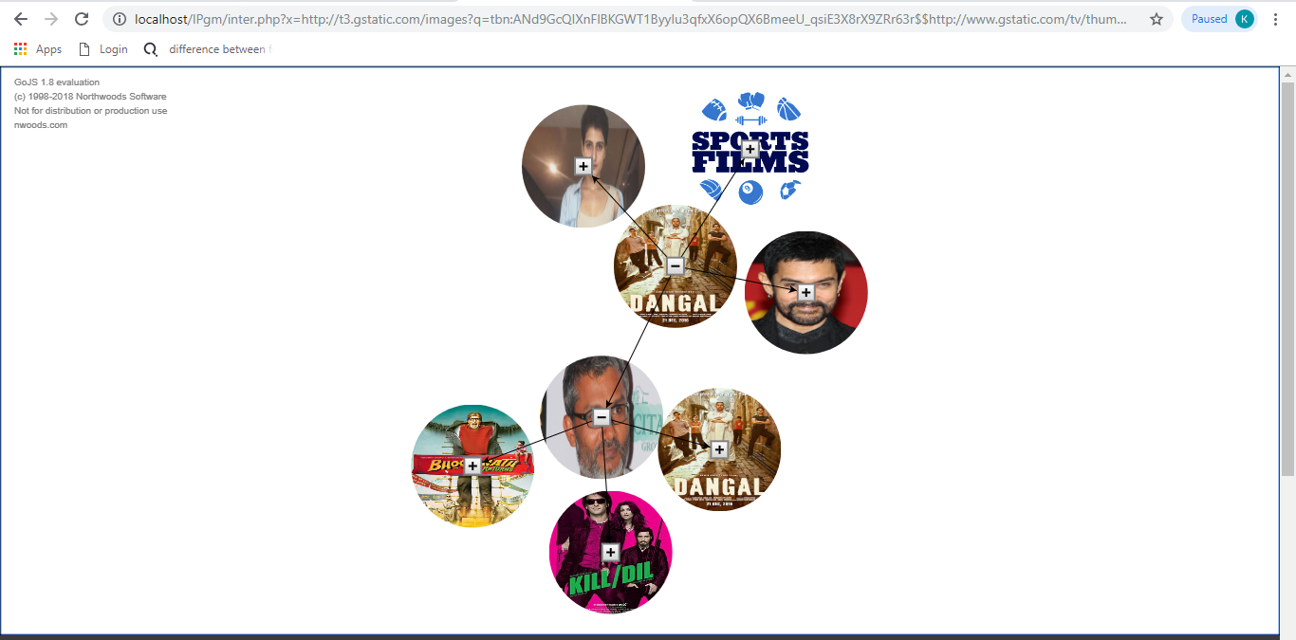

Fig: 4.2 – Web structure page

The same page has recommendations done to the user based on the genre and the movies that he has viewed before.

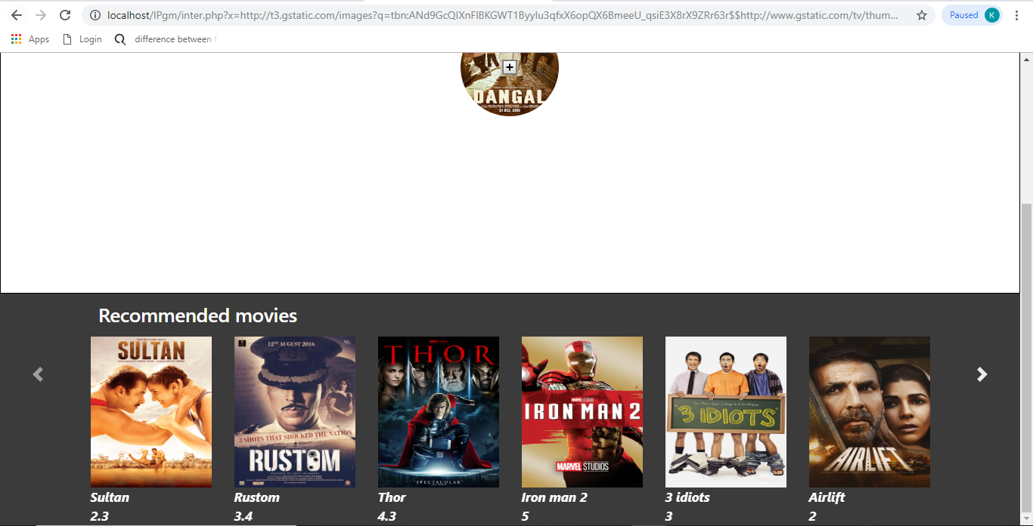

Fig: 4.3 – Recommendation available to the user on Web structure page.

Login (Main page): a pop up in the main page to log user into the site.

14

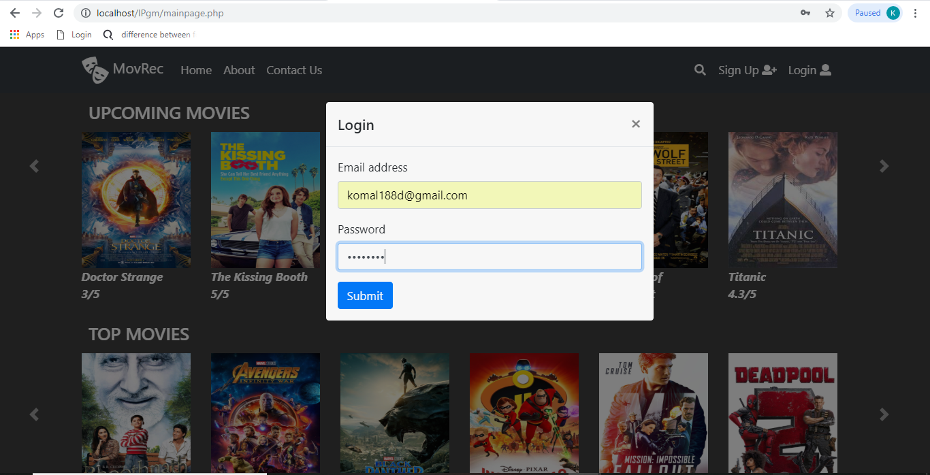

Fig: 4.4 –Login modal on the Main page

Login page: A new page to allow user to login if he is not on the main page.

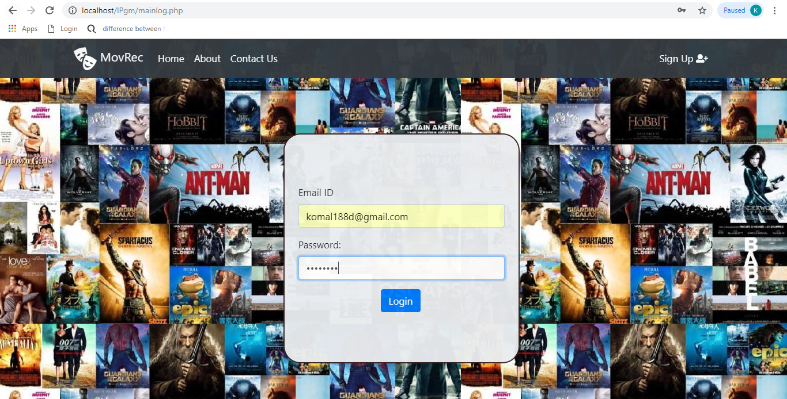

Fig: 4.5 –Login page

Sign up page: Lets the user create his account if he has not created an account yet.

15

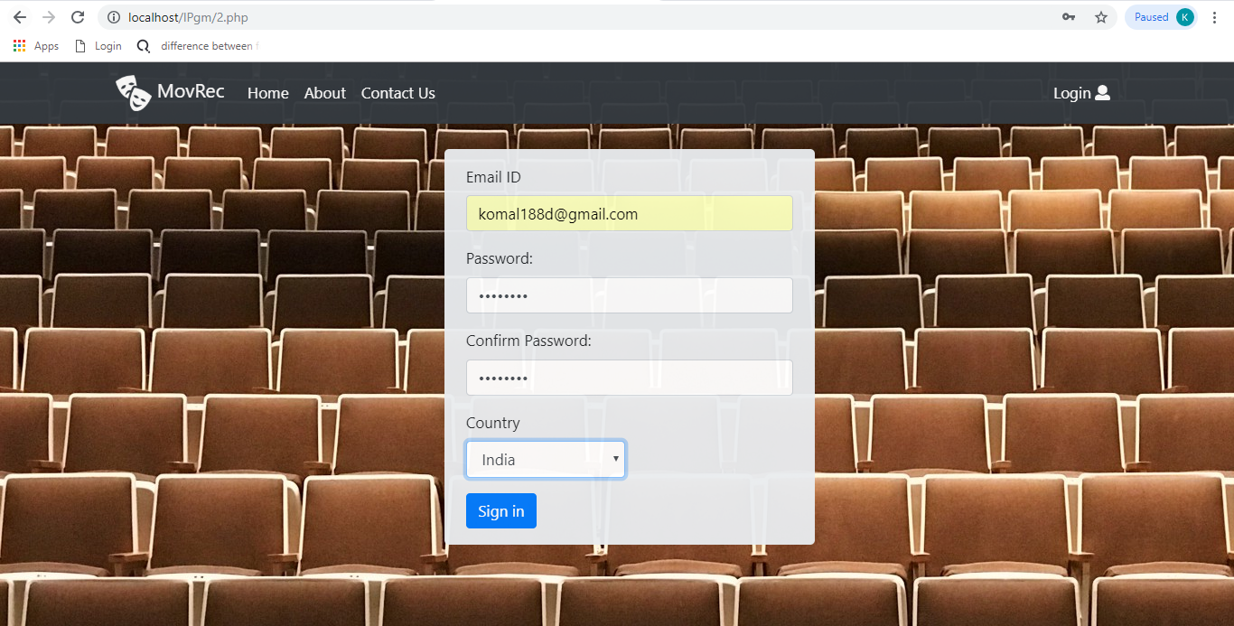

Fig: 4.6 – Sign up page

Search page: allows the user to search for a particular movie of his choice. If the movie is present it will display the movie on clicking which it can go to web structure.php. If not present it will display an error message.

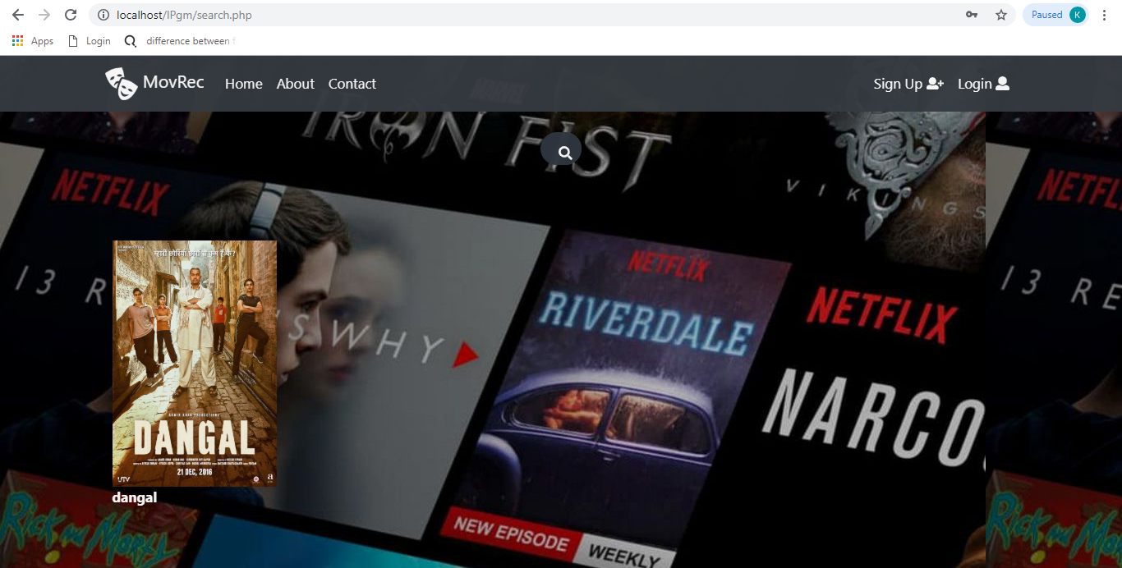

Fig: 4.7 – Search page

16

Contact us page: The ways in which a user can get in touch with us for queries related to login or signup or any other issue are displayed on this page.

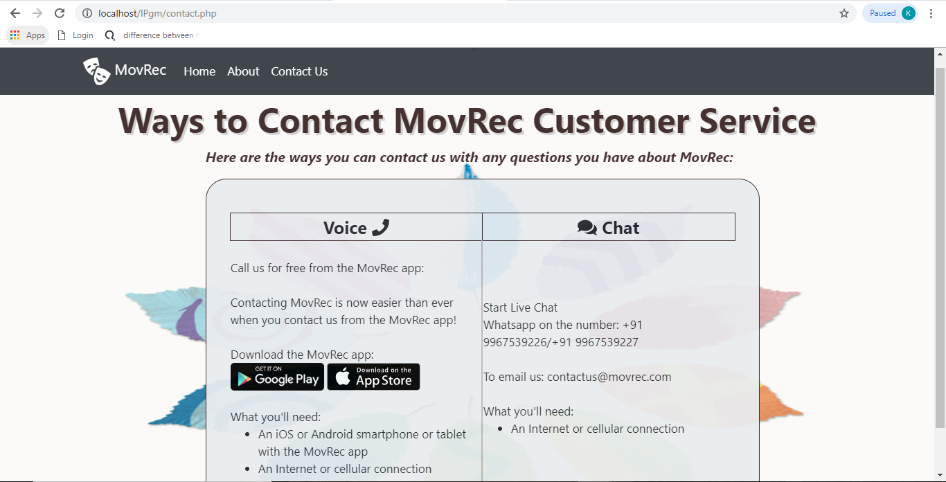

Fig: 4.8 –Contact Us page

About us page: Displays to the user the authenticity of the site and the creators of the website.

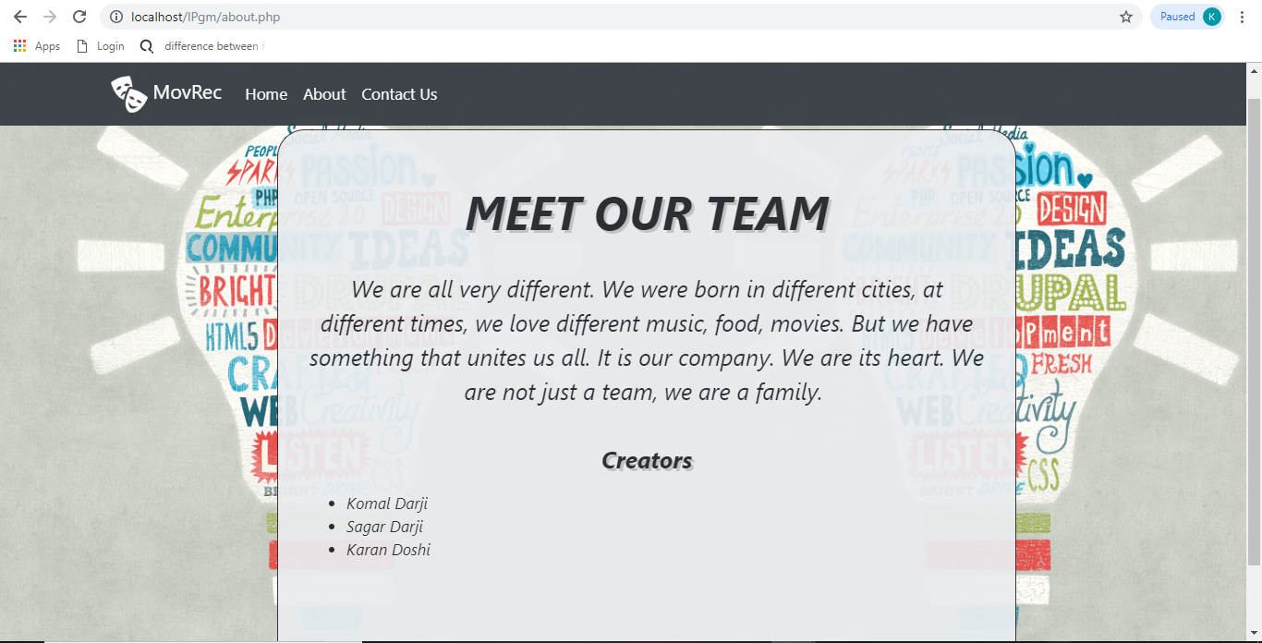

Fig: 4.9 –About page

**17**

1. **Testing and Deployment**

|  |  |  |  |  |
| --- | --- | --- | --- | --- |
| **Test Case ID** | **Test Case** | **Expected Output** | **Actual Output** | **Result** |
| 1 | Login Username and Password | Login Successful | Login Successful | Pass |
| 2 | Registration | Registration Successful | Registration Successful | Pass |
| 3 | Recommendation | Recommendation successful | Recommendation Successful | Pass |
| 4 | Logout | Logout Successful | Logout Successful | Pass |

Fig: 5.1–Testing and Deployment table.

1. **Future Scope**

Because of the attractive UI , the ease to understand and go about the website; the website can be expanded for TV shows and plays etc. For future there can be another panel so as to book tickets for a particular movie, find available theatres nearby and also recommend theatres on the basis of the past selections made by the user. This will make the website a full-fledged movie recommendation and booking website. The user will be notified as and when the choice of his movie is about to release or has been released. The project is intended to serve as a foundation for a future, better optimised version that might be submitted on Google Play Store as well.

1. **References**

[**https://gojs.net/latest/index.html**](https://gojs.net/latest/index.html)

[**http://www.diva-portal.org/smash/get/diva2:1219240/FULLTEXT01.pdf**](http://www.diva-portal.org/smash/get/diva2:1219240/FULLTEXT01.pdf)

[**http://studentnet.cs.manchester.ac.uk/resources/library/3rd-year-projects/2015/dan.manoli.pdf**](http://studentnet.cs.manchester.ac.uk/resources/library/3rd-year-projects/2015/dan.manoli.pdf)

[**http://www.ijesrt.com/issues%20pdf%20file/Archive-2016/November-2016/63.pdf**](http://www.ijesrt.com/issues%20pdf%20file/Archive-2016/November-2016/63.pdf)

[**https://www.sciencedirect.com/science/article/pii/S1110866516300470**](https://www.sciencedirect.com/science/article/pii/S1110866516300470)

18

**https://www.researchgate.net/publication/308494000_A_Review_of_Latest_Web_Tools_and_Libraries_for_State-of-the-art_Visualization**